Gott prüft Abraham – Bibeltext

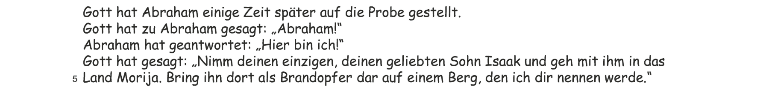

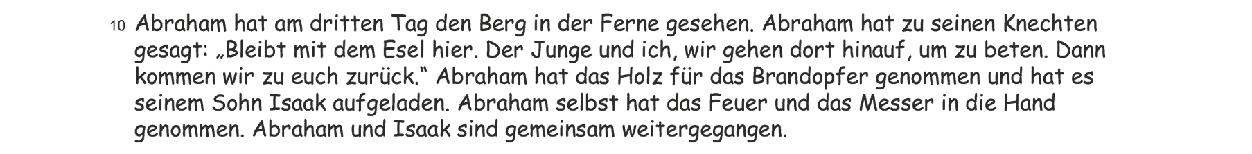
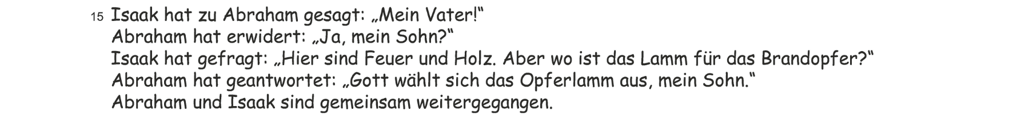

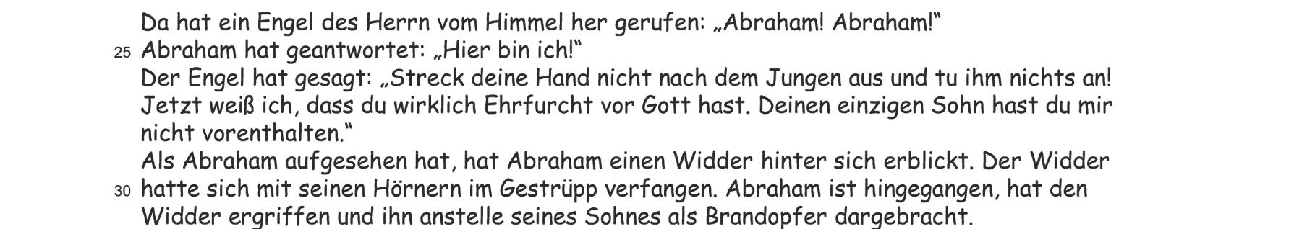

(Gen 22,1–13)

